Trustee Board Members
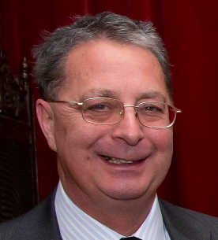
Keith Reed, Chairman
Keith has been Chair of Trustees for several years. He is a retired civil servant, who previously worked in the DWP. Keith has considerable expertise in project management, risk management and information assurance.
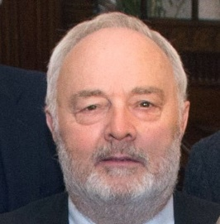
Richard Harris MBE, Vice-Chairman
Richard has been a trustee with the charity for over 20 years. He is a retired property surveyor, with particular expertise in building maintenance and leases.

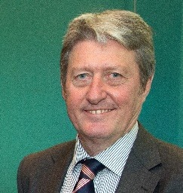
Tony Crawley, Honorary Treasurer
Tony is a retired chartered accountant, and was formerly a partner with local accountancy firm MHA Tait Walker. Tony has been our Treasurer for well over ten years.

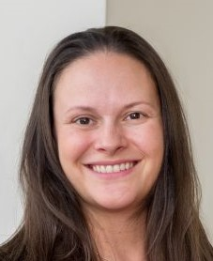
Angela Carver
Angela is an Associate solicitor with Sinton’s Law Firm specialising in employment law. She is a skilled negotiator and very experienced in dispute resolution and tackling discrimination at work.


Gillian Roll
Gillian has recently joined the Trustee Board. She has many years’ experience of working in strategy, research, policy and innovation in previous jobs and is her organisations lead on Aspirations activity.


Hani Fawzi
Hani has a broad range of skills which he acquired through different careers as a medical doctor. He is now a Director of projects and has an interest in finance and language.

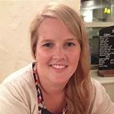
Claire Irving
Claire works in Education Development at Newcastle University. She is particularly interested in skills and training.

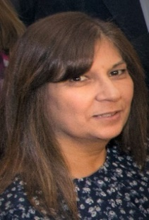
Sangeet Jaidka
Sangeet has had a long career in public finance. She currently works for a local Housing Association. She is particularly keen on financial matters, especially fundraising.

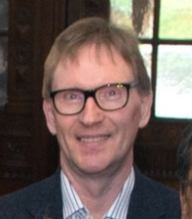
Ian Mackintosh
Ian is semi- retired from a long career in local government finance. Ian now works part time for an arts charity working with disabled people in Gateshead.

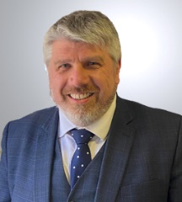
Stuart Parker
Stuart is an Associate Solicitor with local law firm Pepperells. He specialises in family law, and has both expertise and a keen interest in children’s welfare matters.

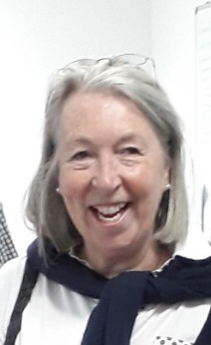
Christine Purdon
Christine ran her own travel business for many years. She was a volunteer advisor with Citizens Advice Newcastle, and is passionate about supporting volunteers.

Oliver Holmes
Oliver is a Director of operations for 3 businesses surrounding commercial energy and has quite a strong understanding of business, process and reporting, presenting and marketing.
Clare Maclaren
Clare has previous experience as a volunteer with a local Citizens Advice in Scotland. Claire has many years experience of governance in third sector organisations and schools and has become adept at deciphering accounts, IT, Social Media, contributing to and chairing meetings and facilitating discussions, training and group work.

